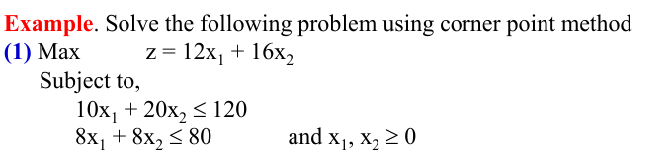

2. So the following LP problem by simplex method:
Max z = 15X + 40Y
Subject to,
2X+3Y ≤ 60
X+4Y ≤ 40
X,Y ≥ 0
3.
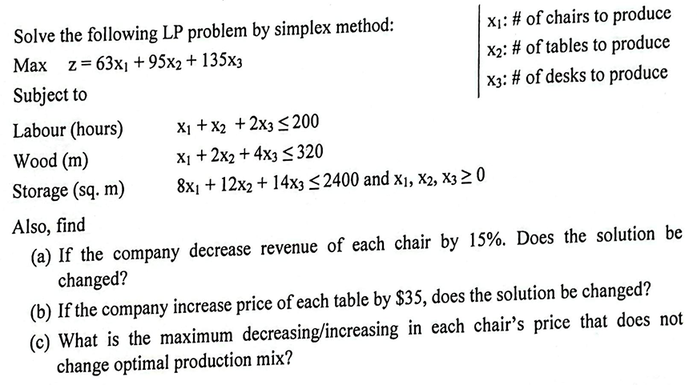
4. Find BFS by Vogel’s Approximation Method (VAM) and find minimum transportation cost.
Source | Destination |  |  | supply
Source | D | E | F | supply
A | 5 | 8 | 4 | 50
B | 6 | 6 | 3 | 40
C | 3 | 9 | 6 | 60
Demand | 20 | 95 | 35 | 150

5. Find BFS by Vogel’s Approximation Method (VAM) and find minimum transportation cost.

Source | Destination
Source | P | Q | R | S | Total
A | 5 | 8 | 3 | 6 | 30
B | 4 | 5 | 7 | 4 | 50
C | 6 | 2 | 4 | 5 | 40
Total | 30 | 20 | 40 | 30

6. Find BFS by Vogel’s Approximation Method (VAM) and find minimum transportation cost.
Factories | Warehouse |  |  |  |  | Supply
Factories | W1 | w2 | W3 | W4 | W5 | Supply
F1 | 4 | 7 | 8 | 5 | 6 | 15
F2 | 6 | 2 | 5 | 8 | 3 | 10
F3 | 7 | 2 | 5 | 4 | 4 | 15
F4 | 5 | 4 | 7 | 4 | 8 | 25
F5 | 5 | 8 | 7 | 4 | 8 | 15
F6 | 5 | 2 | 6 | 9 | 6 | 20
Demand | 10 | 10 | 15 | 25 | 30
7. Construct mean chart and range chart
Sample | Observation
Sample | 1 | 2 | 3 | 4 | 5
1 | 55 | 48 | 43 | 60 | 58
2 | 60 | 67 | 45 | 54 | 66
3 | 50 | 67 | 72 | 40 | 78
4 | 65 | 78 | 83 | 89 | 60
5 | 67 | 45 | 38 | 39 | 70
6 | 45 | 29 | 33 | 67 | 80
7 | 78 | 76 | 40 | 30 | 80
8 | 69 | 80 | 60 | 65 | 89
9 | 48 | 57 | 65 | 62 | 79
10 | 56 | 76 | 79 | 85 | 84

